**Little Dragonfly Nursery**

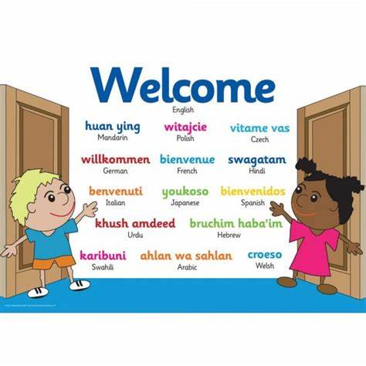**Family welcome pack**

Our Vision “We endeavor to provide a stimulating, safe and nurturing environment that enables children to thrive as they learn through their play.”



****Our Nursery

Dear New Family,

A very warm welcome to Little Dragonfly Nursery, we feel privileged that you have chosen our nursery for your child. This welcome pack is designed to give you valuable information on the aims, organisation and learning that happens at nursery throughout the day, and will hopefully answer many of your questions. However, we are aware that a brochure has its limitations, so I would encourage you to come along and talk to our staff in person or ring us if you have further questions. All our contact details are at the end of this pack. We value our parent’s contributions tremendously and believe that home and nursery working in partnership can provide the best possible learning experiences for your child.

As a parent we understand your child’s well-being is paramount – and it is equally important to us. At Little Dragonfly Nursery, we endeavor to provide a stimulating, safe and nurturing environment that enables children to thrive as they learn through their play experiences.

We understand that entrusting your child/children to the care of others is an important step to help you, our experienced staff will arrange a settling in period to suit your family. From your child’s first day with us, our staff will keep in close contact with you, communicating at every stage.

Meet our team!

**Nursery Manager**

Georgia Greenaway

**Nursery Deputy Manager/Senco**

Bernadette Burke-Whyte

**Baby room**

Lauren Greenhall

*Apprentice – Yasmin Yusuf*

**Toddler room**

Vicky Royston & Hannah Childs

*Apprentice – Lucy Kelly*

**Pre-school**

Debbie Rogers & Sophie O’Brien

*Apprentice – Aiva Mckillen*

**1:1 Practitioner’s**

Bernadette Burke-Whyte, Vicky Royston & Megan Moorcroft

**Nursery Cook**

Louisa Greenaway

**Staff roles within our nursery**

Georgia Greenaway – Manager, Designated Safeguarding Lead

Bernadette Burke-Whyte – Deputy Manager, SENCO, Designated safeguarding lead

Megan Moorcroft- Level 2 SENCO, Designated Fire Officer

Lauren Greenhall- Designated Health and Safety Officer



What do I Bring to Nursery?

To ensure your child has everything they need at nursery, we ask parents to supply a bag for nursery containing the following:

**Water Bottle:**

Please provide a named water bottle each session for your child to always have access to. (We do have a water dispenser available but a child’s own bottle does encourage them to drink more) We also provide fresh milk or water at snack times and lunch time as well.

**Weather appropriate clothing:**

• A waterproof coat

• Wellington boots (These can stay at nursery or brought to each session. Please ensure these are labelled)

• Warm hat in winter and summer hat in summer

• All in one waterproof for winter (This allows children to enjoy outdoor play whatever the weather!)

**Dress for Mess!**

Our children have lots of sensory play activities and creative activities to join in with – please dress your child for mess so that they can enjoy these activities to the fullest. We do provide aprons but children can be in the sensory/messy areas without an apron and are likely to get splashes and dabs on their clothes. Dressing for mess allows children to fully explore. As they get older we do encourage self-care and independence.

**Spare clothes:**

At least 2 tops and 3 pairs of underwear, socks and bottoms if your child is toilet training - Crocs/Jelly shoes can be a good alternative to shoes or wellies whilst toilet training to allow them to be cleaned and dry quickly. It is useful for all children to bring a spare set of clothes in case of getting wet/muddy etc and needing changed.

**Any comforters:**

A dummy can be stored for your baby and a comforter teddy/blanket or toy are welcomed to help your child settle and soothe them. Nappies/Pull-ups and **Nappies/Cream:**

A supply of nappies/pull ups is essential, and you may bring your own wipes/cotton wool if a particular brand is preferred. If you wish for nappy cream to be applied please provide a named pot/tube that can be kept at nursery or in your child’s bag.

**Sun cream:**

 In the summer we ask for all children to arrive to nursery with sun cream already applied and if they are staying for a full day session we ask for a bottle to stay at nursery clearly labelled to allow it to be reapplied in the afternoon.

Baby milk & weaning

All bottles and teats needed throughout the day should be provided daily by parents/carers. They must be clearly named and will be stored for use throughout the day. We have a steriliser that we use to sterilise bottles, teats and feeding utensils during the nursery day. We always ask parents/carers to state which milk their child has whether it is formula, expressed breast milk, cow’s milk or any other type of milk. We provide fresh cow’s milk daily at no extra cost to your child’s session. We request any other milks are provided from home and clearly labelled with your child’s name. Staff will prepare and make fresh bottles of milk as and when required. We have experiences with children with milk intolerances so we can support you with this if it becomes apparent during the weaning process. Our baby room staff are experienced in supporting babies through weaning choices such as baby led weaning. We are fully supportive of encouraging children to explore new tastes and textures independently. Snacks and lunches are prepared by being chopped into finger sized pieces. When babies are weaning, we work with parents during the process to make sure new tastes are slowly being introduced. We encourage babies to try a wide variety of flavours and textures as they grow; almost all babies enjoy experimenting – although often they will go through phases of refusing a food that they couldn’t get enough of the previous week!

Please fill our your All About Me form to ensure we are following the same approach as you at home and update us with any changes.

Potty Training

It is very important not to rush your child into using the potty or toilet. As a parent, we can often feel pressured into presuming they are ready as they approach two years old, however often they show signs they are ready closer towards three years old and we will support families when you are ready.

All our staff believe children will display signs indicating they are ready such as:

• Knowing when they have got a wet or soiled nappy.

• They get to know when they are having a wee and may tell you they are doing so or know when they need a wee and tell you in advance.

• The gap between wetting a nappy is at least an hour. (If it’s less, potty training may fail and at the very least will be extremely hard work for you.)

• They can or are beginning to dress themselves with little or no adult support.

Our staff will work in partnership with you to create a smooth transition from nappies into pull ups/underwear. If your child wears nappies/pull ups, then it’s parents preference whether they want to supply them daily or to bring them in ‘bulk’ and we will let you know when supplies are running low.

Spare clothes:

If your child is potty training, we recommend you supply at least 2 tops and 3 pairs of underwear, socks and bottoms. Crocs/Jelly shoes can be a good alternative to shoes or wellies whilst toilet training to allow them to be cleaned and dry quickly. Trousers need to have an elasticated waist to allow your child to easily pull them down and up, buttons and poppers often result in frustration and accidents. Trousers with an elasticated waist are great!

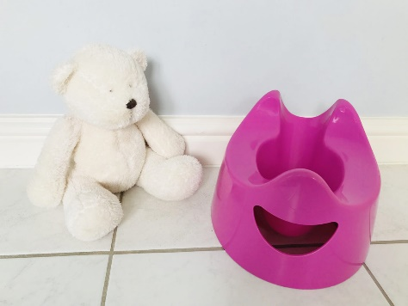



Lunch & snacks

Snacks are provided in the morning and afternoon for all children. Cooked Lunches are also prepared fresh daily by our cook Louisa providing a hot & healthy lunch option. You may also provide a cold packed lunch for your child if you wish.

Week 1

Week 2





Fee’s

**0-2yrs**

£57 full day

£36 morning session

£35 afternoon session

£280 full week

**2yrs +**

£56 full day

£35 morning session

£34 afternoon session

£275 full week

Holiday club

£28 full day

£135 full week

**Supplement fee for funded children**

£10.50 full day

£7.50 morning session

£5 afternoon session

Please ensure all fees are paid in advance not arrears. Reference child’s name when sending payment.

Thank you.

*Woolford House ltd*

*04-00-03*

*56646259*

The Early Years Foundation Stage (EYFS)

The EYFS seeks to provide:

• Quality and consistency in all early years settings, so that every child makes good progress and no child gets left behind.

• A secure foundation through learning and development opportunities that are planned around the needs and interests of each individual child and are assessed and reviewed regularly.

• Partnership working between practitioners and with parents and/or carers. • Equality of opportunity and anti-discriminatory practice, ensuring that every child is included and supported. There are four guiding principles that shape practice in early years settings:

• Every child is a unique child, who is constantly learning and can be resilient, capable, confident, and self-assured.

• Children learn to be strong and independent through positive relationships.

• Children learn and develop well in enabling environments, in which their experiences respond to their individual needs and there is a strong partnership between practitioners and/or carers.

• Children develop and learn in different ways and at different rates. The framework covers the education and care of all children in early years provision, including children with special educational needs and disabilities.

The 7 areas of learning

There are 7 areas of learning and development that must shape our educational provision, these areas are all important and interconnected. The first three are particularly crucial for igniting children’s curiosity and enthusiasm for learning, and for building their capacity to learn. These three areas are called the Prime Areas. These are followed with four Specific Areas, through which the prime areas are strengthened and applied. Please ask to see our photo display in the hallway that shows a huge range of our exciting activities in each area to give an insight into how your child will explore the 7 areas of learning.

Prime Areas: • Communication and Language (C&L) • Personal, Social and Emotional Development (PSED) • Physical Development (PD)

Specific Areas: • Literacy (L) • Mathematics (M) • Understanding the World (UW) • Expressive Arts and Design (EAD)

These areas are used to plan your child’s learning and activities.

Our staff ensure these activities are targeted to your child’s individual interests, needs and stage of ability. There are also many resources available for children to choose themselves and develop their independence. The seven areas of learning are achieved through Play!

Our staff ensure that our play opportunities are varied and exciting for our children.

What is a key persons role

The key person is a named practitioner who has responsibilities for a small group of children, they are there to help the child feel safe and secure. The role is important for both child and parent and it is an approach set out in the EYFS. The key person approach makes sure relationships between staff and children are ‘attentive, responsive, stimulating and affectionate.’

A key person ensures that within the day-to day demands of the nursery, each child feels welcomed, cherished and cared for as an individual to create a smooth transition from the home environment to nursery each session they attend. Children feel settled and happy and are more confident to explore and thus become more capable learners. Your child’s key person will be chosen to match the sessions they attend and with consideration to whom the child gravitates towards and develops a fun, affectionate and secure attachment.

You will be informed who your child’s key person is and they will identify themselves to you. Where possible this person will pass on daily information and any messages about your child’s activities, enjoyment, and progression. Your key person will keep a record of development through uploading photos and observations to your online learning journey: Tapestry for you to view, comment on and contribute to.

Please approach your key person at any time to discuss your child’s next steps.

Your child’s progression

Sharing your children’s progress and achievements are vitally important to us. There are a range of ways that we communicate your child’s progress with you:

Newsletters: We have termly newsletters that will inform you of Parent Consultation dates where you are invited in to discuss your child’s progress with your child’s key worker.

Key Worker System: You are encouraged to communicate regularly with your key worker at drop off and pick up times to share information and your key worker can provide you with information about your child’s next steps that we are working towards at Nursery. Each room has a Next Steps Tree on display that you are welcome to look at, at any time.

Tapestry – Our Online Learning Journeys: When you filled out your registration forms it would have included a letter about Tapestry and an accompanying consent form. We will create a secure account with the details you provide that enables us to upload photographs, observations and reports relating to your child’s time with us. As a parent this allows you to view exciting achievements via a computer or smart phone. If you do not have internet access, then we can provide the service here for you if needed.

Open Door Policy: All our staff are happy to answer any queries or questions and the management office door is open between 7:30 and 18:00 if you need to pop in for a chat.

You can also email on [littledragonflynursery@outlook.co.uk](mailto:littledragonflynursery@outlook.co.uk) or call us on 0151-4284646 at any time.